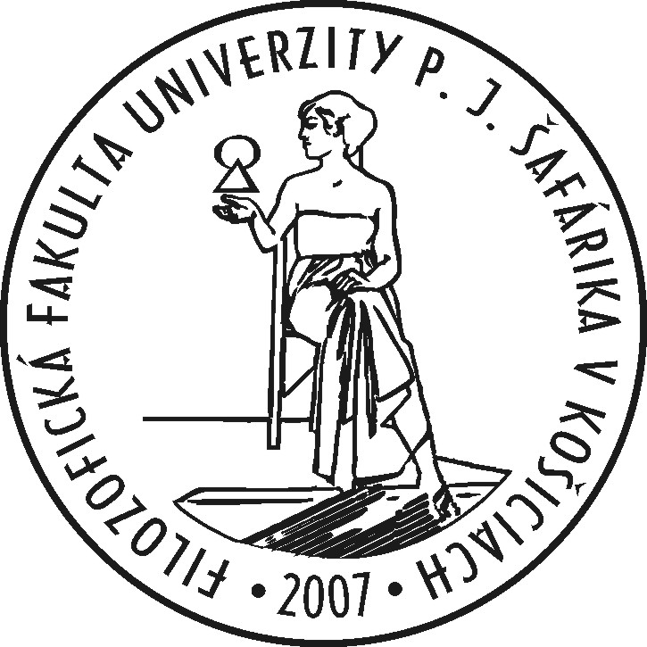

PROFESSIONAL CURICULUM VITAE

PERSONAL PROFILE
Psychology graduate and PhD. student
Proactive and creative researcher
Intervention programs based on mindfulness for helping professions
Teaching experience with undergraduate students and some PhD. informal supervision

Name: Mgr. Simona Weissová
Adress: Sídlisko Rimava 26, 979 01, Rimavská Sobota
Telephone: +421 915243153
E-mail: simonkaweissova@gmail.com

EDUCATION
2009-2013: Pedagogical and Social Academy in Lučenec
Field of study: preschool pedagogy, kindergarten teaching

2013-2016: Bachelor's degree in psychology: Pavol Jozef Šafárik University in Košice, Faculty of Arts, Department of Psychology
Thesis: Examination of Fenomenon Known as Subcoscious Goal Conflict Occuring Outside of Conscious Awareness
Supervisor: Mgr. Pavol Kačmár, Phd.

2016-2018: Master's degree in psychology : Pavol Jozef Šafárik University in Košice, Faculty of Arts, Department of Psychology
Thesis: Mindfulness Techniques as a Means of Coping with the Mental Workload in Helping Professions
Supervisor: Doc. PhDr. Margita Mesárošová, Csc.

2018 – present: Phd. student, Pavol Jozef Šafárik University in Košice, Faculty of Arts, Department of Psychology
Project Proposal: Intervention Programs Based on Mindfulness for Helping Professions as a Tool for Improvement of Self-Care and Professional Quality Life
Supervisor: Doc. PhDr. Margita Mesárošová, Csc.

VOLUNTEER EXPERIENCE AND COMMUNITY INVOLVEMENT
2016 – Telephone Line of Children's Trust, counselor
2018- present: Slovak Associaton of Psychology Students and Graduates - active member

CONFERENCES ATTENDED
Czech Transpersonal Conference 2016
Czech Transpersonal Association
pasive attendance
Complex Trauma and It's Effects on Child Development 2016
Slovak Institute of Family Therapy and Therapy of Attachment
pasive attendance
Negative Consequences of Practicing Helping Professions 2017
Pavol Jozef Šafárik University in Košice
pasive attendance
Psychology of Work and Organisation 2018
Pavol Jozef Šafárik University in Košice
active attendance Article: Mindfulness Based Intervention as a Tool for Coping with Mental Workload in Helping Professions
School Psychology: History and Perspectives 2018 Pavol Jozef Šafárik University in Košice
active attendance Article: Intervention Programs for Helping Professions in Context of Self Care

LANGUAGE SKILLS
English – B2

COMPUTER SKILLS
Word, Excel, PowerPoint, SPSS Statistics, Amos Graphics (basic user customer skills)

References Available Upon Request

Short Academic Biography
Simona Weissová holds a master's degree in Psychology from the Pavol Jozef Šafárik University in Košice. Now she is doctoral student, objective is to obtain Phd. degree.
Her field of study is applied social psychology on Department of Psychology . Her supervisor is associate professor Margita Mesárošová. Her appoinment at the faculty involves teaching undergraduate students (subject Základy Psychológie), academic work and research and habilitation writing – a professional thesis based on scholarly acomplishments, research and publications. Her research deal with the issue of intervention programs for helping professions as a tools for elimination of negative consequences of helping – burnout syndrome,depersonalisation, compassion fatigue, mental workload, secondary traumatic stress and perceived stress. She started her research one and half year ago, by her master's thesis. Her research interest also include improvement of the positive aspects of helping – compassion satisfaction and globally quality of professional life of these workers – through psychological mechanisms of mindfulness and self-compassion. Many recent studies point to the fact that mindfulness and self-compassion are important traits of personality resistent to negative consequences of helping, especially burnout. The goal of her dissertation is to draw conclusions from the investigation in this area of study. Currently she is engaged in the implementation of the grant project APVV-14-0921 „Self care as a factor of coping with negative consequences of helping professions“ (2015-2019). She working on publication of coursebook and monography with other solutionists. She also works on verifying questionnaire of mindfulness (Cognitive-Affective Mindfulness Scale- Revised) to Slovak population adaptation, with the intention of application for current grant research.

